

**YEAR: 7**

**2024**

**SUBJECT: Science**

**Answers**

**TEST: Classification**

**TIME: 45 minutes**

**QUESTIONS: 10 Multiple Choice (10 marks)**

**9 Short Answer (32 marks)**

**TOTAL MARKS: 42 marks**

**DO NOT WRITE ON OR MARK THIS PAPER**

**Part A: Multiple Choice Questions (10 marks)**

**Indicate Answer on Answer Sheet.**

1. Carl Linnaeus created a double naming system, which is used by scientists around the world today. Select from the options below how a scientific name is given to an organism.
2. *Species genus*
3. *Species phylum*
4. *Phylum species*
5. *Genus species*
6. Select from the options below which organism would be the most closely related to the great hammerhead shark. The scientific name for the great hammerhead shark is *Sphyrna mokarran*.

1. *Carcharodon carcharias*
2. *Sphyrna lewini*
3. *Carcharhinus mokarran*
4. *Carcharhinus leucas*
5. Scientists classify organisms because:
   1. it makes it easier to identify organisms.
   2. there are only a few organisms that differ from each other.
   3. most discoveries in biology have already been made.
   4. all organisms have characteristics in common.
6. Organisms can be grouped into five major kingdoms. These are:
   1. mammals, fish, birds, amphibians and reptiles.
   2. animalia, fungi, monera, plantae and protists.
   3. animalia, fungi, insects, plantae and algae.
   4. animalia, plantae, insects, birds and reptiles.
7. The Linnaean system of classifying living things starts with large groups called:
8. Phyla
9. Species
10. Classes
11. Kingdoms
12. Members of kingdom animalia:
13. Are multicellular and gain energy from the sun.
14. Are multicellular and can gain energy from other non-living things.
15. Are unicellular and can gain energy from themselves.
16. Are unicellular and can gain energy from other living things.
17. The reason for using structural characteristics (rather than colour or size) for classification is:
    1. structural features are easy to observe.
    2. individuals of the same type can differ in colour.
    3. organisms change size as they grow.
    4. all of the above.
18. The main difference between vertebrates and invertebrates is that:
19. Vertebrates have a skeleton and invertebrates have an exoskeleton or no skeleton at all.
20. Vertebrates have an external skeleton and invertebrates have an internal skeleton.
21. Vertebrates are birds and invertebrates are fish.
22. Vertebrates are fish and invertebrates are birds.
23. Which kingdom does this creature belong to?

Top of Form

1. Animalia
2. Aves
3. Protista
4. Monera
5. One of the features of the Plantae Kingdom is that all the organisms are autotrophs. Which of the following is the best definition for autotroph.
6. 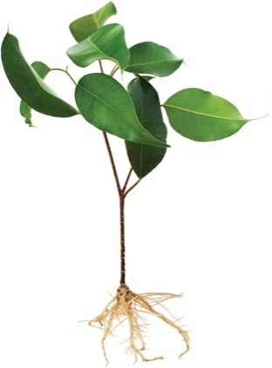A single celled organism.
7. A multicellular organism.
8. An organism that is able to produce its own food.
9. An organism that is not able to produce its own food.



**SEMESTER TWO 2024**

**Classification Science Test:**

**ANSWER BOOKLET**

**NAME:**

**FORM:** **DATE:**

Multiple Choice Short Answer Total

**/32**

**/10**

**/42**

**SECTION ONE:** Multiple choice answers

Cross (X) through the correct answer.

|  |  |  |  |  |
| --- | --- | --- | --- | --- |
| **1** | a | b | c | d |
| **2** | a | b | c | d |
| **3** | a | b | c | d |
| **4** | a | b | c | d |
| **5** | a | b | c | d |
| **6** | a | b | c | d |
| **7** | a | b | c | d |
| **8** | a | b | c | d |
| **9** | a | b | c | d |
| **10** | a | b | c | d |

**ASSESSMENT KEY**

|  |  |
| --- | --- |
| **I CAN STATEMENTS** | **QUESTIONS** |
| **MUST**  Classifies organisms using observable similarities and differences and applying simple classification keys. | 3, 4, 5, 6, 7, 8, 11, 12, 13, 14, 15, 16, 17, 20 |
| **SHOULD**  Classifies organisms using observable similarities and differences, constructing and applying classification keys. | 1, 10, 11, 17, 18 |
| **COULD**  Classifies unfamiliar organisms using observable similarities and differences, constructing and applying varied classification keys. | 2, 9, 17, 19 |

**Part B: Short Answer Questions (32 marks)**

**Answer in the spaces provided.**

11.Biologists use factors or criteria to determine whether something is living or non-living.

**a)** Using MR N GREWW, write down the 8 criteria that an object must satisfy to be considered living. (4 marks)

|  |  |
| --- | --- |
| **M** | Movement (1/2 mark) |
| **R** | Reproduction (1/2 mark) |
| **N** | Nutrition (1/2 mark) |
| **G** | Growth (1/2 mark) |
| **R** | Response (1/2 mark) |
| **E** | Exchange Gas (1/2 mark) |
| **W** | Waste (1/2 mark) |
| **W** | Water (1/2 mark) |

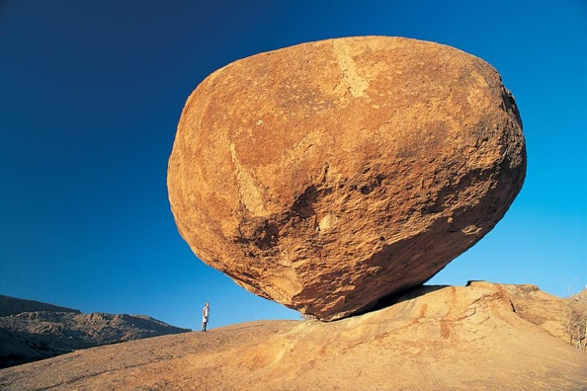  
**b)** This is a picture of a rock.

Sammy thinks rocks are a living thing.

Bobby thinks the rocks are a non-living thing.

i) Who is correct? Bobby or Sammy? (1 mark)

Bobby (1 mark)

ii) Using MR N GREWW, explain your answer. (2 marks)

States that rock does not fit MR N GREWW. (1 mark)

States specific examples of the MR N GREWW that don’t apply to rocks. (1 mark)

12) Describe how to use a dichotomous key. (2 marks)

Example Answer:

Description of each option leading to a different set of two questions. (1 mark)

If you follow key, it will lead you to the identification of the organism you are examining. (1 mark)

Any justifiable/acceptable answer can be awarded a mark (max 2 marks)

13) Do Aboriginal and Torres Strait Islander Peoples use the same or different classification system as Carl Linnaeus’ classification system. **Explain** your answer. (2 mark)

States they are different. (1 mark)

Any justifiable difference. (1 mark)

14)  
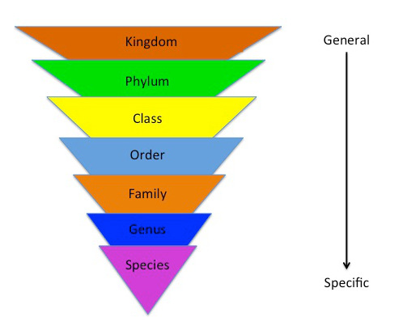

Identify the two missing groups from the Linnaeus classification system (1 mark)

Phylum (1/2 mark)

Family (1/2 mark)

15) Below is a branching classification key for invertebrates. Fill in the animals in the boxes of legs and no legs. Then use the key to fill in the table below it. (5 marks)

*Please write the names of the animals in the boxes after the first question in the dichotomous key and then write the number you think the animal is in the table below.*

Does the organism have antennae?

Does the organism have wings?

Wings

1

No Wings

2

Antennae

3

No Antennae

4

All animals: Worm, Bee, Slug, Spider

Question: Does the invertebrate have legs?

No Legs

Animals: Worm

Slug (1/2 mark for both) ___________________

Legs

Animals: Bee

Spider (1/2 mark for both)

|  |  |
| --- | --- |
| Animal | Which box does this animal belong in? (put a number in each box from the key above) |
| Earthworm | National Geographic | 4 (1 mark) |
| Honey Bees Pollinate Trade Opportunities - TradeVistas | 1 (1 mark) |
| Spiders, facts and information | 2 (1 mark) |
| Australian man gravely ill after eating slugs 'for a dare' - Telegraph | 3 (1 mark) |

16) Tabular keys are also used for classification. Use the tabular key below to correctly identify the class of the following animals. (3 marks)

|  |  |  |  |
| --- | --- | --- | --- |
| 1 | Does the animal have feathers? | Feather’s present  Feathers not present | Aves  Go to 2 |
| 2 | Does the animal have fur or feathers? | Hair or fur present  No hair or fur | Mammalia  Go to 3 |
| 3 | Does the animal have fins? | Fin’s present  No fins present | Pisces  Go to 4 |
| 4 | Does the animal have scales? | Has moist skin, no scales  Has scales | Amphibian  Reptilia |

|  |  |  |
| --- | --- | --- |
| Herpetologists describe new species of snake found in stomach of ... | Laughing Kookaburra - Best Bird Photos Australia | Swordfish | fish | Britannica |
| Class: Reptilia (1/2 mark) | Class: Aves (1/2 mark) | Class: Pisces (1/2 mark) |
| Frog Skin Yields Potent Painkillers, but None Clinic Ready | The ... |  | Clownfish | National Geographic |
| Class: Amphibian  (1/2 mark) | Class: Mammalia  (1/2 mark) | Class: Pisces (1/2 mark) |

17) In the Kingdom Animalia organisms are identified by the type of skeleton present in the body. Complete the table below, identifying the type of skeleton of the animal and whether this classifies the organism as a vertebrate or invertebrate. (3 marks)

|  |  |  |
| --- | --- | --- |
| Organism | Endoskeleton/ exoskeleton/ no skeleton | Vertebrate or invertebrate |
| Octopus  Octopus - Alchetron, The Free Social Encyclopedia | No Skeleton  (1/2 mark) | Invertebrate  (1/2 mark) |
| Prawn  Are prawns sustainable | Marine Stewardship Council | Exoskeleton  (1/2 mark) | Invertebrate  (1/2 mark) |
| Fish  Why do fish feel slimy and lose scales when you touch them? - BBC ... | Endoskeleton  (1/2 mark) | Vertebrate  (1/2 mark) |

18) Henry has a group of animals (pictured below) he has been researching and wants to classify using a dichotomous key. Construct a classification key for Henry to use. The key has been started for you. (5 marks)

(1 mark) (3 total) per question box filled in. (Highlighted Red)

(0.5 mark) (2 total) per box filled in identifying animal (Highlighted Green)

*Students are expected to draw the final the two boxes for animal identification. No marks for identification if they have not completed the flow chart.*

***Half the dichotomous key has been completed for you. You must finish BOTH sides to gain full marks. (Hint: make sure you fill in the question and identify the animals).***

**Toucan**

**(1/2 mark)**

**Anaconda**

**(1/2 mark)**

**Llama**

**(1/2 mark)**

**Jaguar**

**(1/2 mark)**

**No**

**Toucan and Anaconda**

**(1 mark)**

**Relevant question**

**(1 mark)**

**Relevant question**

**(1 mark)**

|  |  |  |  |
| --- | --- | --- | --- |
| Jaguar | Toucan | Anaconda | Llama |
|  | Toucan Facts For Kids | What Do Toucans Eat | DK Find Out | Angolan Python for Sale | Pythons for sale, Python, Angolan |  |

19) Describe the difference between an endoskeleton and an exoskeleton. (2 marks)

Description of Endoskeleton (internal skeleton) - (1 mark)

Description of Exoskeleton (external skeleton) - (1 mark)

20) The Kingdoms are divided up by the arrangement of cells in an organism. (2 marks)

Using your knowledge of the common features of Kingdoms fill in the table below.

|  |  |  |
| --- | --- | --- |
| Kingdom | Unicellular or multicellular | Cell wall present? |
| Animalia | Multicellular  (1/2 mark) | No  (1/2 mark) |
| Plantae | Multicellular  (1/2 mark) | Yes  (1/2 mark) |

**END OF TEST**